Specification Document- SurveyBox

SurveyBox is a browser-based application for creating, editing and viewing surveys.

Get a URL to your new survey

**Design prototype**

Watch the survey's results

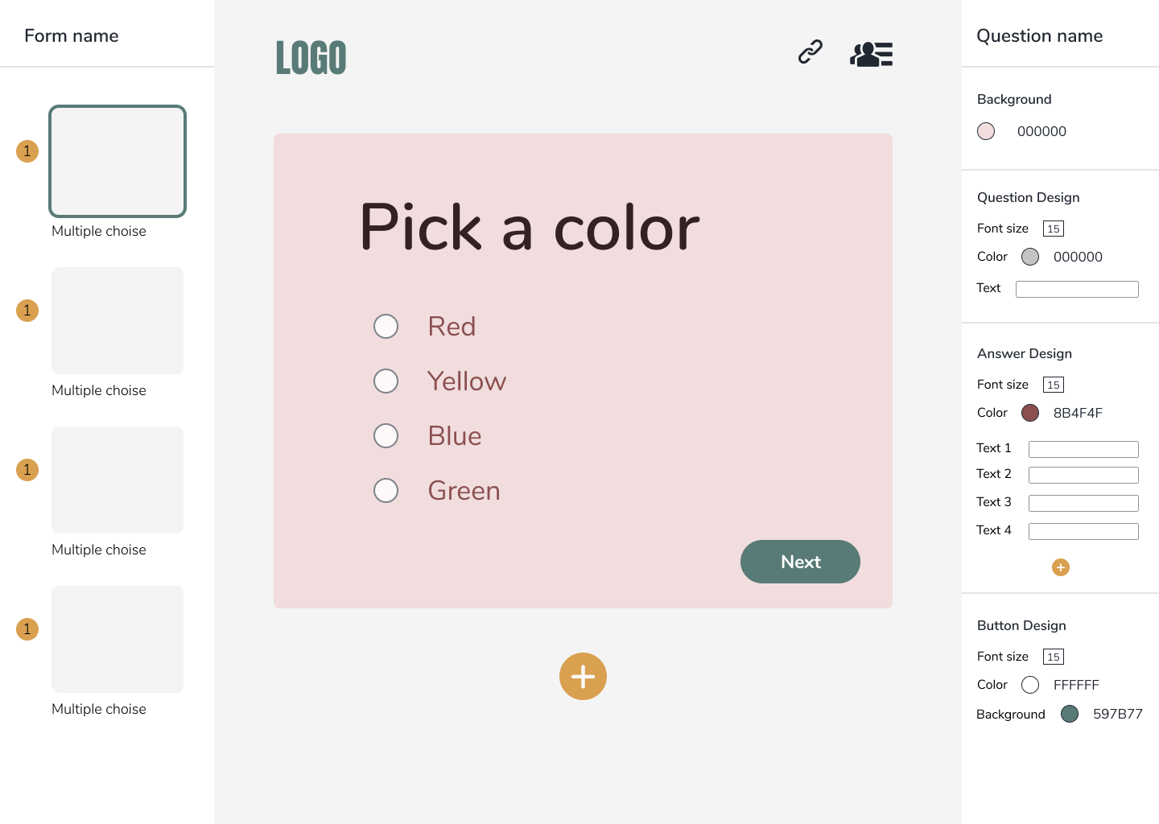

Preview each question as you edit it

Edit and style each question

Survey timeline

Changeable question name

Changeable survey name

Add more pages/questions

**Code design**

This project will be written in TypeScript using React and Redux libraries.

The UI is designed by me and will be implemented using CSS and react syntax HTML.

The UI is divided to components lime so:

1. Left side bar- displays the survey's timeline: their order, type and preview (?). Also has the option to change the survey's name.

The current displayed question is marked with a distinct border.

1. Right side bar- displays the styling and editing options of the current question.
2. Header bar- displays the logo and 2 options:

* copy this survey's URL
* copy the results page URL

1. preview window- a preview of the current question. Previews the changes made in the edit bar immediately.

This window is not interactable.

1. Add button- when clicked, displays the pages available to add.

Like so:

**Notes**

* The first implementation of the project will focus on one survey only (one JSON file and one URL – explained below).

Also, the data will not be stored in a database at this point.

There won't be a registration/login process at this point.

There won't be a drag and drop in the left side bar at this point (for changing the questions order).

The results will be the last feature to implement- if the survey is edited, we need to check if the results are no longer relevant and delete them.

Every user can answer the survey multiple times because there is no registration at this point.

* The changes and edits will be logged and saved every few seconds.

To do so, I will build a small backend server (not sure in what language, Java/C#/Nodejs?) that saves the changes in a JSON file.

When the URL is opened, the JSON will load as an interactable survey.

The results will also be saved in a different JSON file.

**Survey's JSON object**

each page object/component will implement the interface- IPage.

In addition, they will implement the interface "IStatement" or the interface "IQuestion".

One more interface is INextPage, which is implemented by all pages except goodbye page, which is the last page.

Each interface has its own unique properties, regarding their edit and style options.

**IPage**

interface IPage {

  pageType: string;

  background: string;

  pageName: string;

}

**IQuestion**

interface IQuestion {

  questionType: string;

  questionColor: string;

  questionFontSize: number;

  questionText: string;

  answersColor: string;

  answersFontSize: number;

  answersText: Array<string>;

}

**IStatementPage**

interface IStatementPage {

  headerFontSize: number;

  headerColor: string;

  headerText: string;

  subHeaderFontSize: number;

  subHeaderColor: string;

  subHeaderText: string;

}

**INextClick**

interface INextClick {

  buttonFontSize: number;

  buttonBackground: string;

  buttonTextColor: string;

}